Version ：GV-PF10S1-GG20170216

Shanghai Goodview Electronics Technology Co. Ltd.

Android
10inches LCD multimedia Display
Model:PF10S1

Revision History
Part number | version | Revise Date | Prepared by | Checked by | approval | Remarks
1246001 | GV-PF10S1-GG20170216 | 2017-2-16 |  |  | 

Note：All right reserved by Goodview.Please contact with us for the latest updates.

Product Specification
Display Panel
Panel |  | 10.1inches LED back-light/model:M101WXBI45-AA-01
Active Area(mm) |  | 216.96 (W) ×135.60 (H) mm
Aspect Ratio |  | 16:10
Resolution |  | 1280×800
Brightness |  | 280/350 cd/m2
Contrast Ratio |  | 800:1
Viewing Angle |  | All angles ( R/L 89 (Min.), U/D 89 (Min.))
Color |  | 16.7Mcolors
Color temperature |  | 5500K
Backlight lamp life |  | 30000 hours
Response time |  | 6ms
System
Main board model |  | SWH5128
CPU |  | Rockchip RK3126
GPU |  | ARM Mali-400MP2 GPU
Memory |  | DDR3 512Mbyte,
Storage |  | 8GB eMMC
Operation system |  | Android5.1
Touch
Model |  |  |  | /
Touch type |  |  |  | /
Touch Points |  |  |  | /
Interpolation resolution |  |  |  | /
Touch accuracy |  |  |  | /
Response time |  |  |  | /
Enter mode |  |  |  | /
Smallest touch objects | Single |  |  | /
Smallest touch objects | Multi-point |  |  | /
ports
Signal port |  | /
Network ports |  | LAN*1（10/100MEthernet），wifi (802.11n)、 blue-tooth(4.0)
Storage extension |  | 32GB（max）
Other |  | USB(2.0)*1、RS232*1（3.5mm jack）、POE(24V)
multimedia
Media file formats |  |  | video：MOV, MP4, AVI, MPG, 3PG
 |  |  | audio：MP3
 |  |  | picture：JPEG、BMP、PNG
 |  |  | text：txt
Play mode |  |  | Landscape, vertical screen, full screen, and split screen
Program transmission way |  |  | USB, LAN, Wan transport
Other parameters
Product Size(mm) |  | 239.9（H）×169.2（V）×26.8（D）
Package Size(mm） |  | 333（H）×278（V）×75（D）
VESA（mm） |  | 50*50
Screen hanging mode |  | Landscape, portrait
Menu language |  | Chinese, English
Machine color |  | Black
Weight |  | net：0.5KG gross：2.0KG
Power Consumption |  | 12W(Max)
Speaker |  | stereo 1.5W x8Ω
Watchdog timer |  | /
Timing function |  | multiple time periods programmable power on/off
Management software |  | GTV
Power supply |  | DC 12V
Working temperature |  | 0〜40℃
Working humidity |  | 10% 〜 80%RH
Storage environment |  | - 10 ~ 50 ℃ temperature/ 10% ~ 90% RH humidity
Accessories |  | Warranty card * 1,Remote control * 1, certificate * 1, 12 v power adapter * 1,Network line* 1, safety and environmental considerations * 1,National standard power cord * 1,AAA battery * 2
Certificates |  | CCC

Schematic Drawing

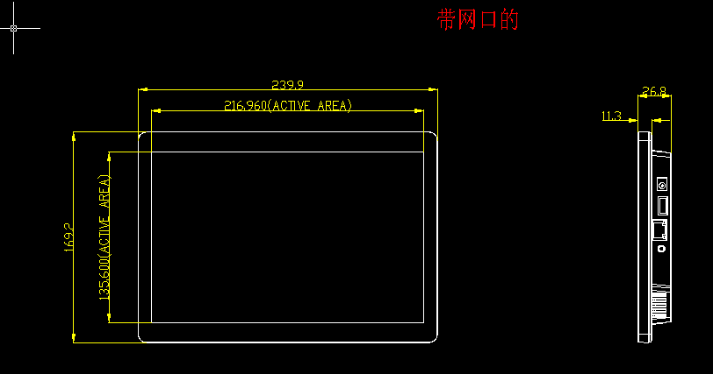
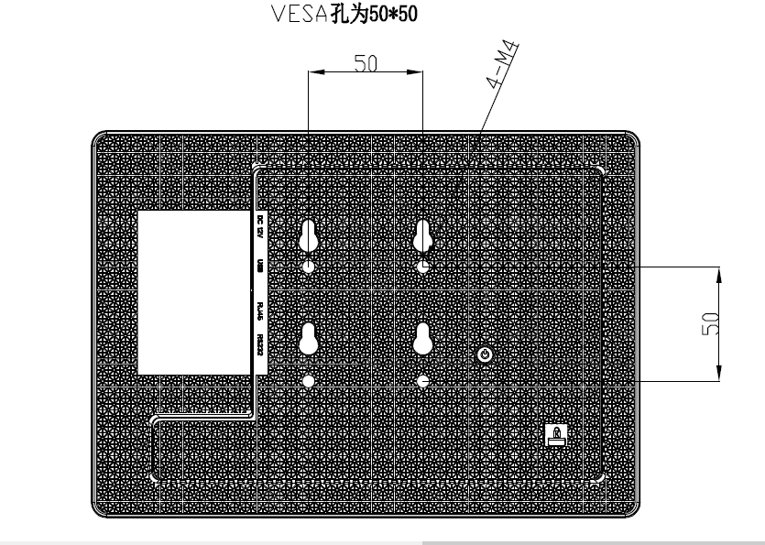

Product Images
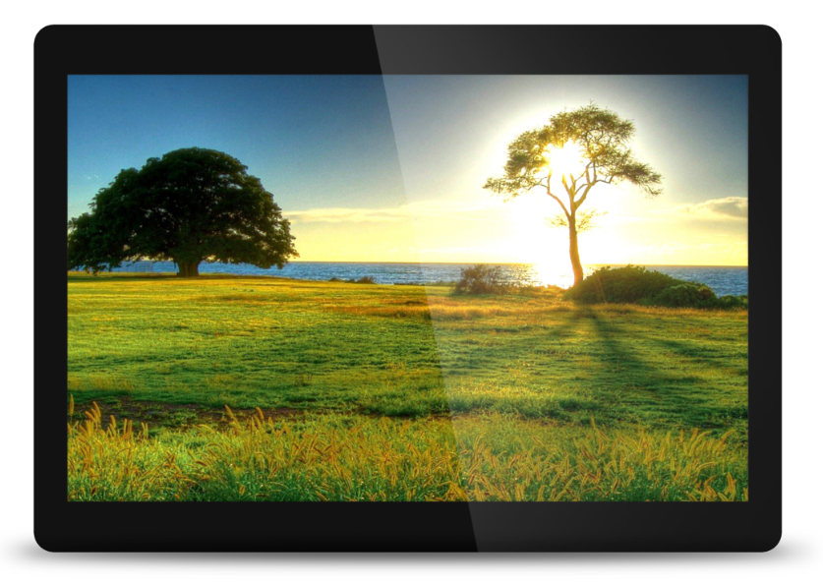
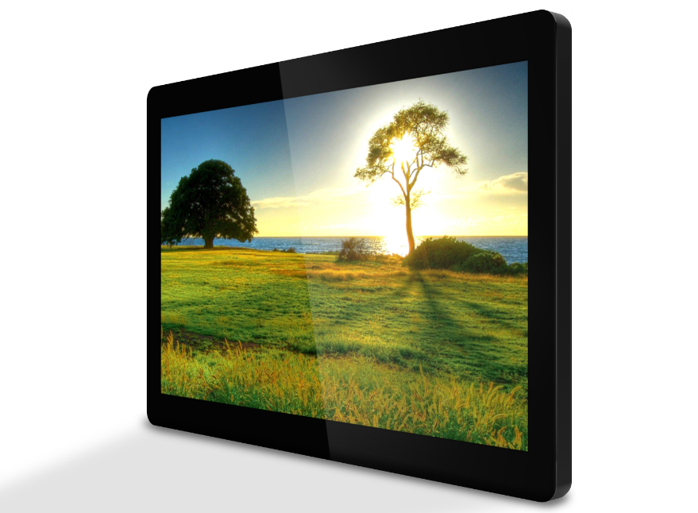
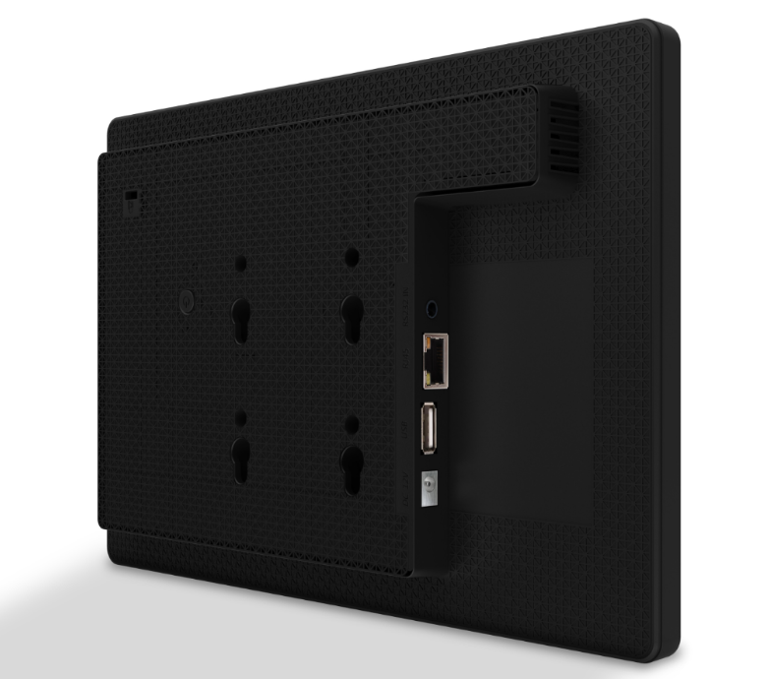
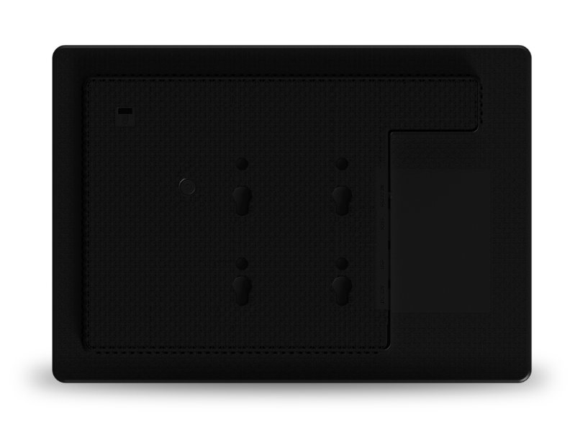

Packaging

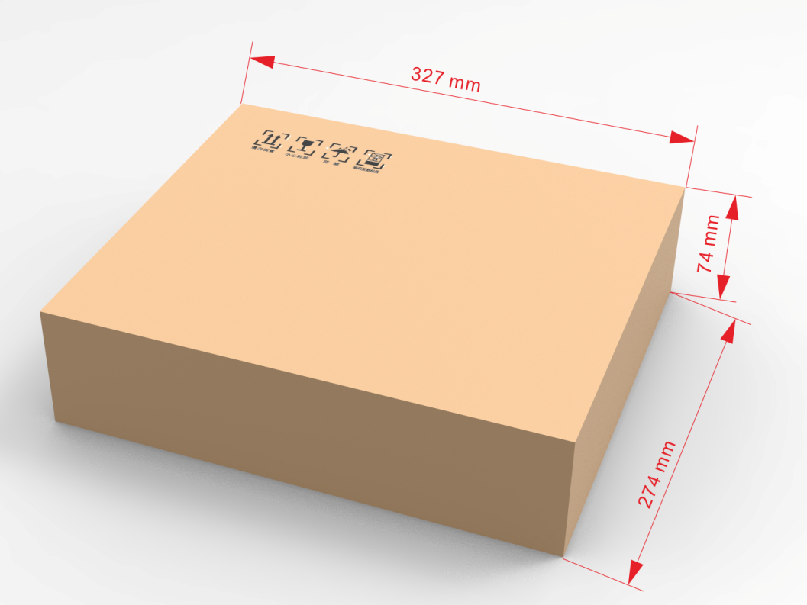

Note：All right reserved by Goodview.

